**Version 2_NEW PROPOSED LIST FOR THE ICD WEBSITE**

**Format Guide:**

Entry 1:

Title:

Thumbnail:

Description:

Link:

**News and Updates** (Existing Tab)

* **2020**
* Clickable **December**

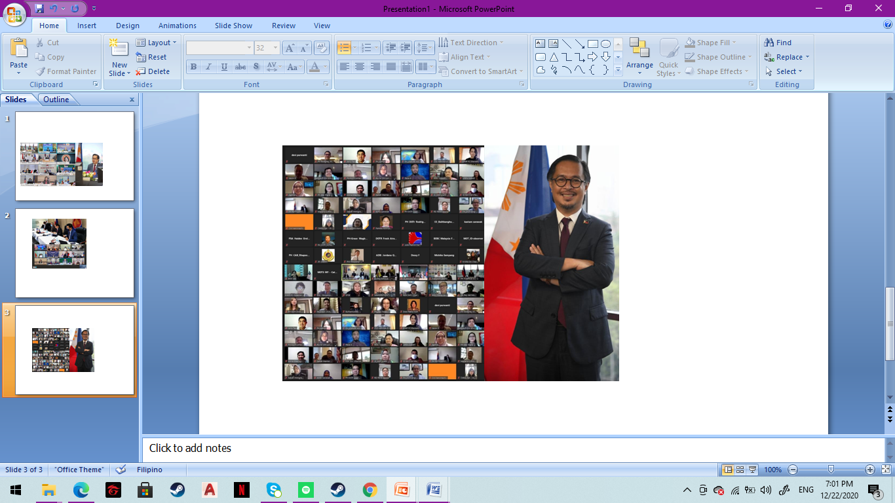

**Special BIMP-EAGA Transport Cluster Meeting**

Increasing multimodal transport connectivity and improving infrastructure through Air, Land, and Sea Linkages despite COVID-19 outbreak were some agenda raised on the Special Brunei Darussalam-Indonesia-Malaysia-Philippines East ASEAN Growth Area (BIMP-EAGA) Transport Cluster virtual meeting yesterday, 21 December 2020.

[View More >](https://www.facebook.com/DOTrPH/posts/1908104875995306)

When ‘View More’ is clicked, the reader will be redirected to:

<https://www.facebook.com/DOTrPH/posts/1908104875995306>

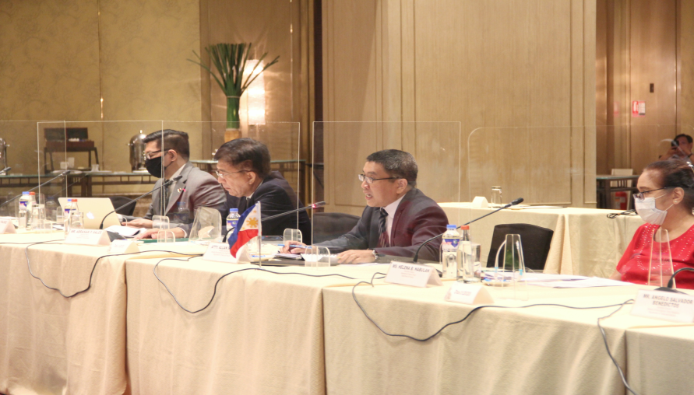

**2nd Session of the Philippines-Hungary Joint Commission on Economic Cooperation**

**The Department of Transportation, represented by Toll Regulatory Board Executive Director, Engr. Abraham P. Sales, recently participated in the Second Session of the Philippine-Hungarian Joint Commission on Economic Cooperation (JCEC) held from 3 to 4 December 2020 in Makati City, Metro Manila.**

[View More >](https://www.dti.gov.ph/news/joint-commission-on-economic-cooperation/)

When ‘View More’ is clicked, the reader will be redirected to: [Philippines and Hungary pursue stronger cooperation at the 2nd Session of the Joint Commission on Economic Cooperation | Department of Trade and Industry Philippines (dti.gov.ph)](https://www.dti.gov.ph/news/joint-commission-on-economic-cooperation/).

* **November**

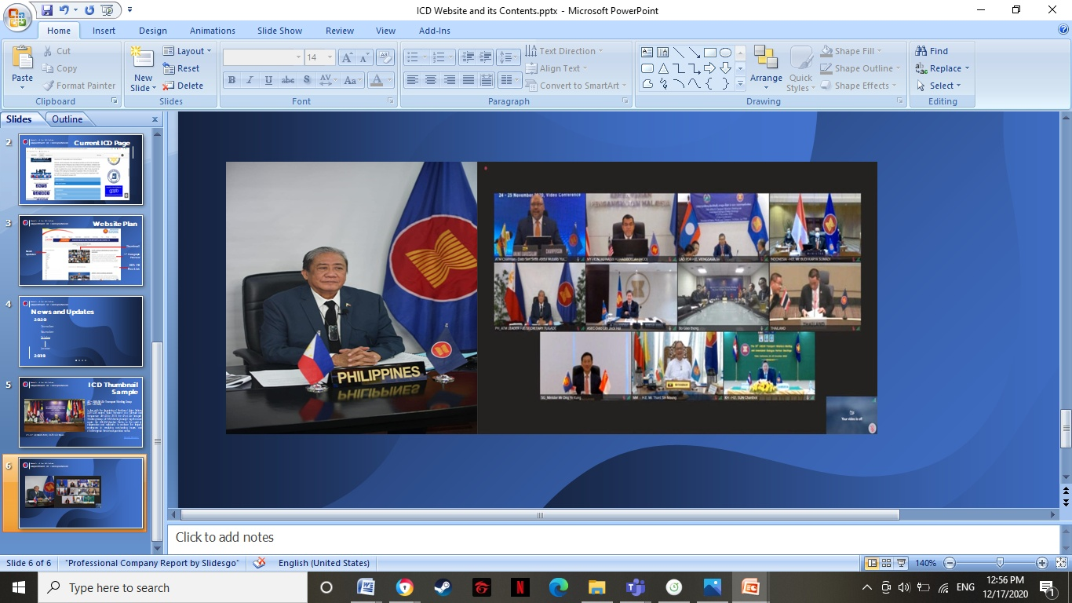

**26th ASEAN Transport Ministers (ATM) and Associated Dialogue Partner Meetings**

Department of Transportation (DOTr) Secretary Arthur P. Tugade joined his ASEAN counterparts during the 26th ASEAN Transport Ministers (ATM) and Associated Dialogue Partner Meetings held through video conference yesterday, 24 November 2020.

[View More >](https://www.facebook.com/DOTrPH/posts/1884697421669385)

When ‘View More’ is clicked, the reader will be redirected to:

<https://www.facebook.com/DOTrPH/posts/1884697421669385>.

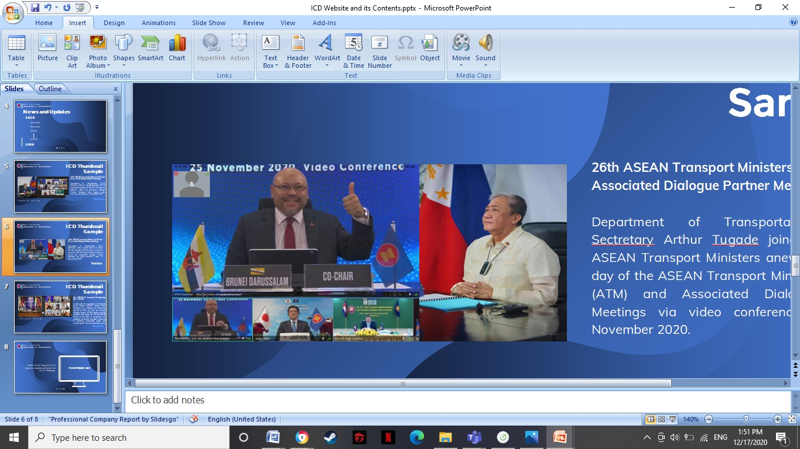

**26th ASEAN Transport Ministers (ATM) and Associated Dialogue Partner Meetings**

Department of Transportation (DOTr) Sectretary Arthur Tugade joined his fellow ASEAN Transport Ministers anew, for the 2nd day of the ASEAN Transport Ministers Meeting (ATM) and Associated Dialogue Partner Meetings via video conference today, 25 November 2020.

[View More >](https://www.facebook.com/DOTrPH/posts/1885018804970580)

When ‘View More’ is clicked, the reader will be redirected to:

<https://www.facebook.com/DOTrPH/posts/1885018804970580>

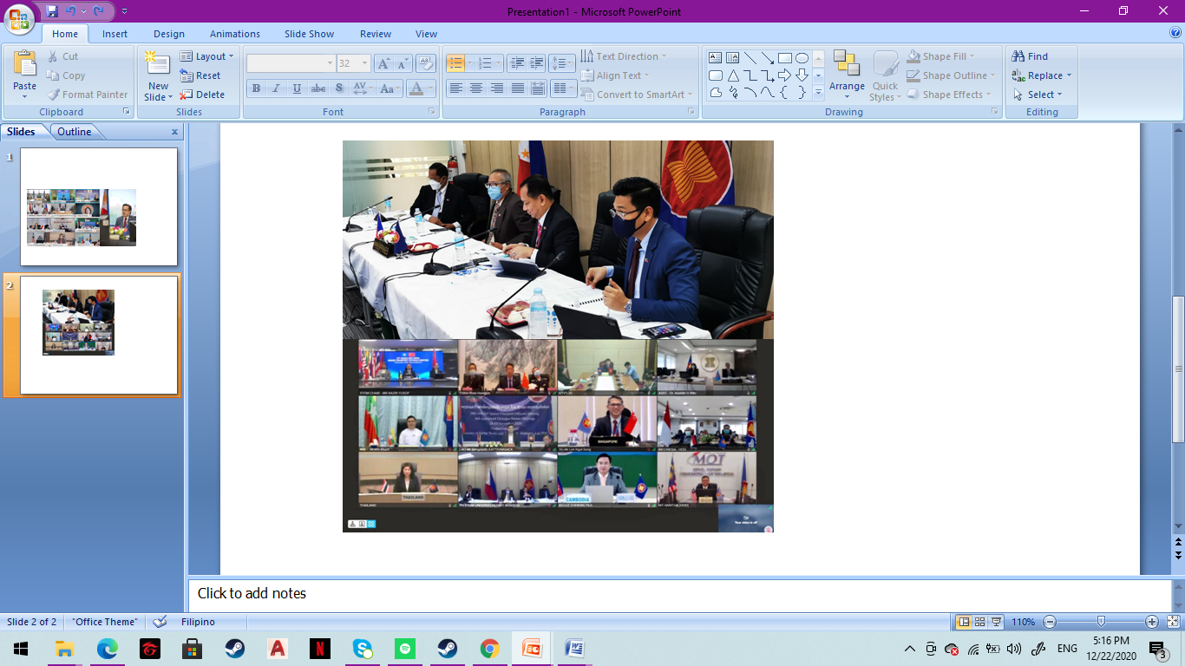

**50th ASEAN Senior Transport Officials Meeting (STOM) and Associated Dialogue Partner Meetings**

The Department of Transportation (DOTr) joined representatives from ASEAN Member States during the 50th ASEAN Senior Transport Officials Meeting (STOM) and Associated Dialogue Partner Meetings held via video conference from 18 to 19 November 2020.

[View More >](https://www.facebook.com/DOTrPH/posts/1879667178839076)

When ‘View More’ is clicked, the reader will be redirected to:

<https://www.facebook.com/DOTrPH/posts/1879667178839076>

* **October**

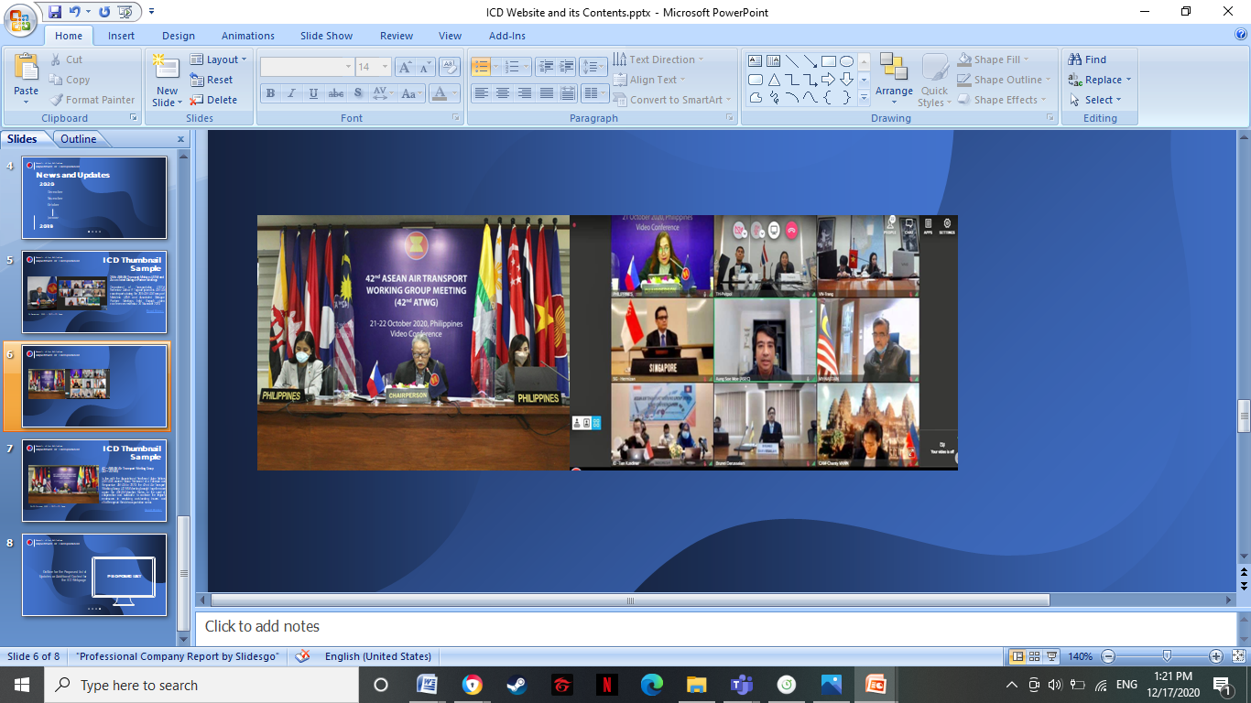

**42nd ASEAN Air Transport Working Group (42nd ATWG)**

In line with the Association of Southeast Asian Nations (ASEAN) Leaders’ Vision Statement of a Cohesive and Responsive ASEAN in 2020, the 42nd Air Transport Working Group (ATWG) Meeting brought together once again the ASEAN Member States, in the spirit of cooperation and solidarity, to continue the region’s endeavors in resolving outstanding issues and challenges in the air transportation sector.

[View More >](https://www.facebook.com/DOTrPH/posts/1852397781566016)

When ‘View More’ is clicked, the reader will be redirected to:

<https://www.facebook.com/DOTrPH/posts/1852397781566016>

* **September**

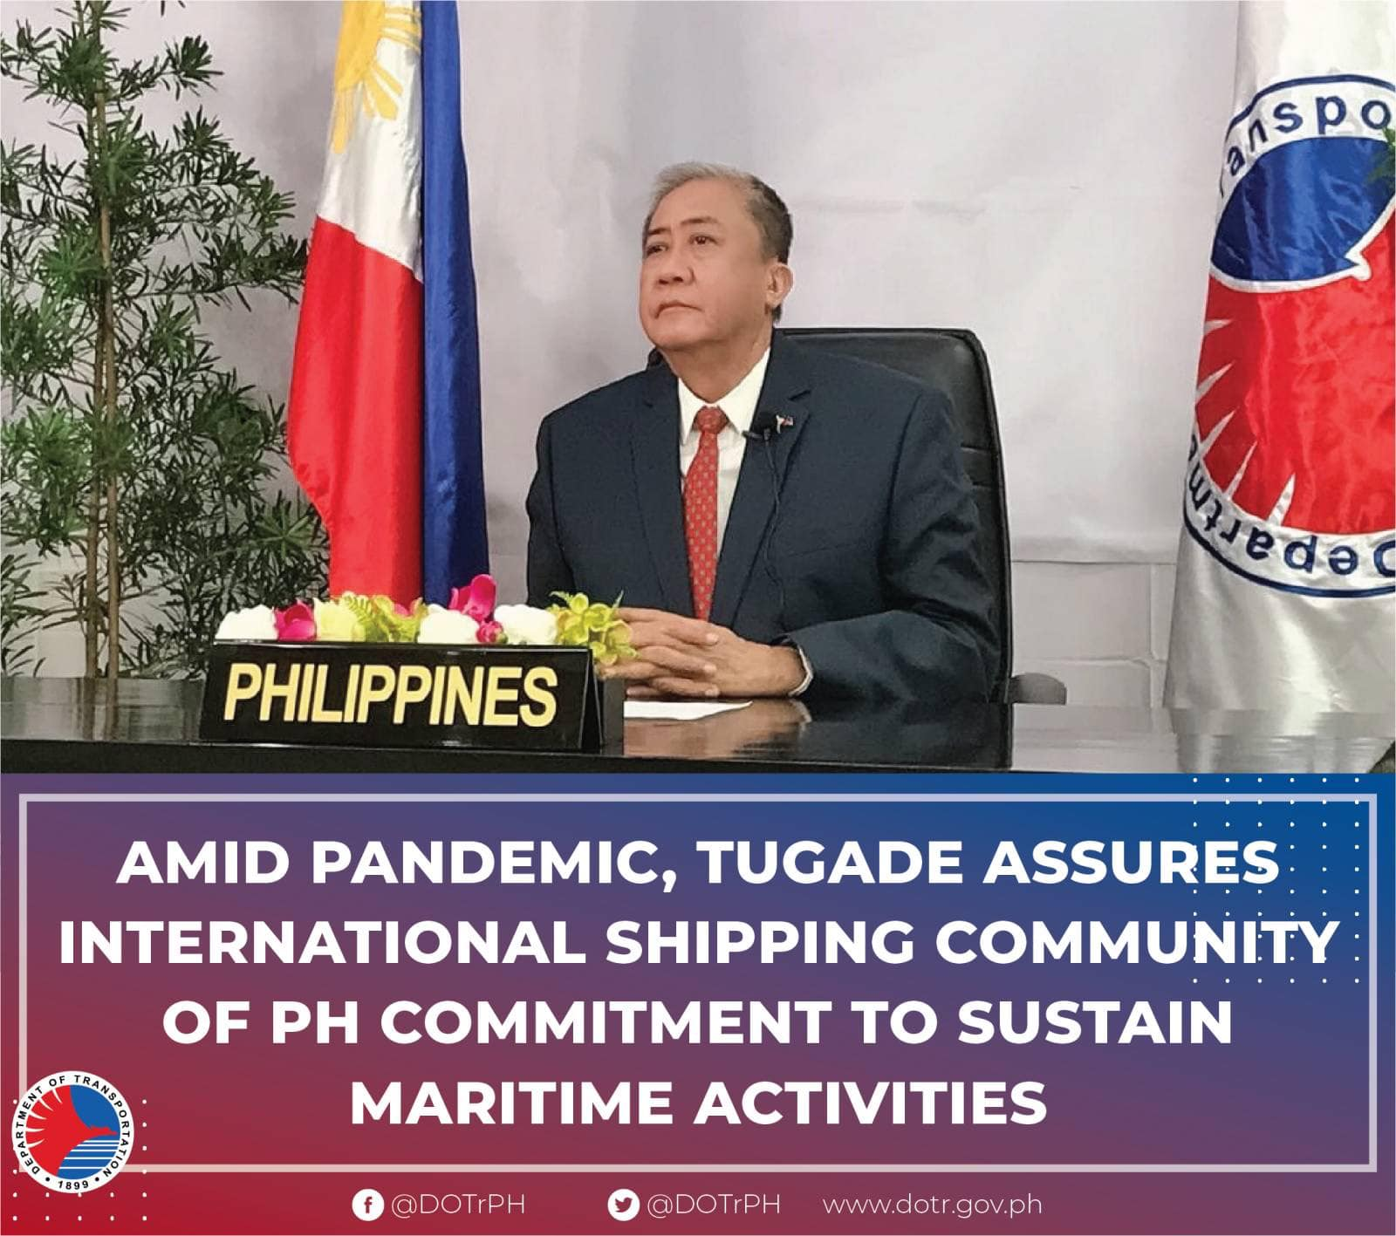

**Secretary Tugade’s Assurance of International Shipping Community of PH Commitment to Sustain Maritime Activities**

Stressing the importance maritime trade and shipping activities play during crucial periods such as the ongoing coronavirus disease 2019 (COVID-19) pandemic, Transport Secretary Arthur Tugade assured the international shipping community of the country’s commitment as an effective partner in global maritime activities.

[View More >](https://www.facebook.com/DOTrPH/posts/1825020340970427)

When ‘View More’ is clicked, the reader will be redirected to:

<https://www.facebook.com/DOTrPH/posts/1825020340970427>

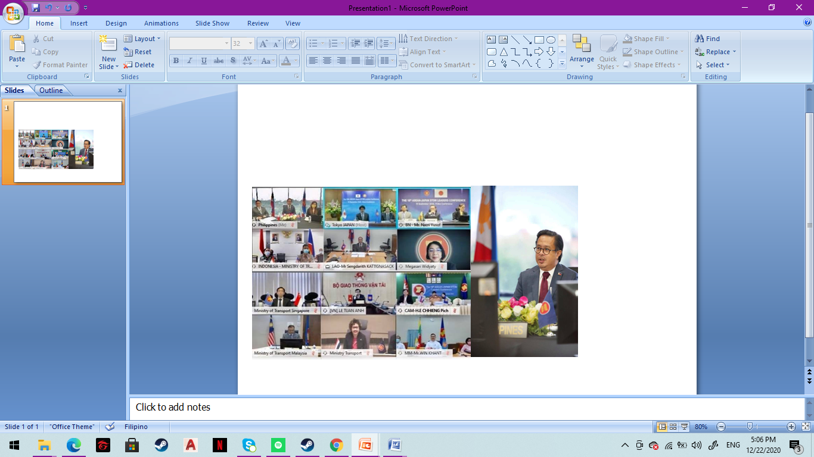

**18th ASEAN-Japan Senior Transport Officials Meeting (STOM) Leaders' Conference**

Representatives of member-states of the Association of Southeast Asian Nations (ASEAN), together with the Japanese delegation, convened during the 18th ASEAN-Japan Senior Transport Officials Meeting (STOM) Leaders' Conference held virtually yesterday, 15 September 2020.

[View More >](https://www.facebook.com/DOTrPH/posts/1816001951872266)

When ‘View More’ is clicked, the reader will be redirected to:

<https://www.facebook.com/DOTrPH/posts/1816001951872266>

* **August**

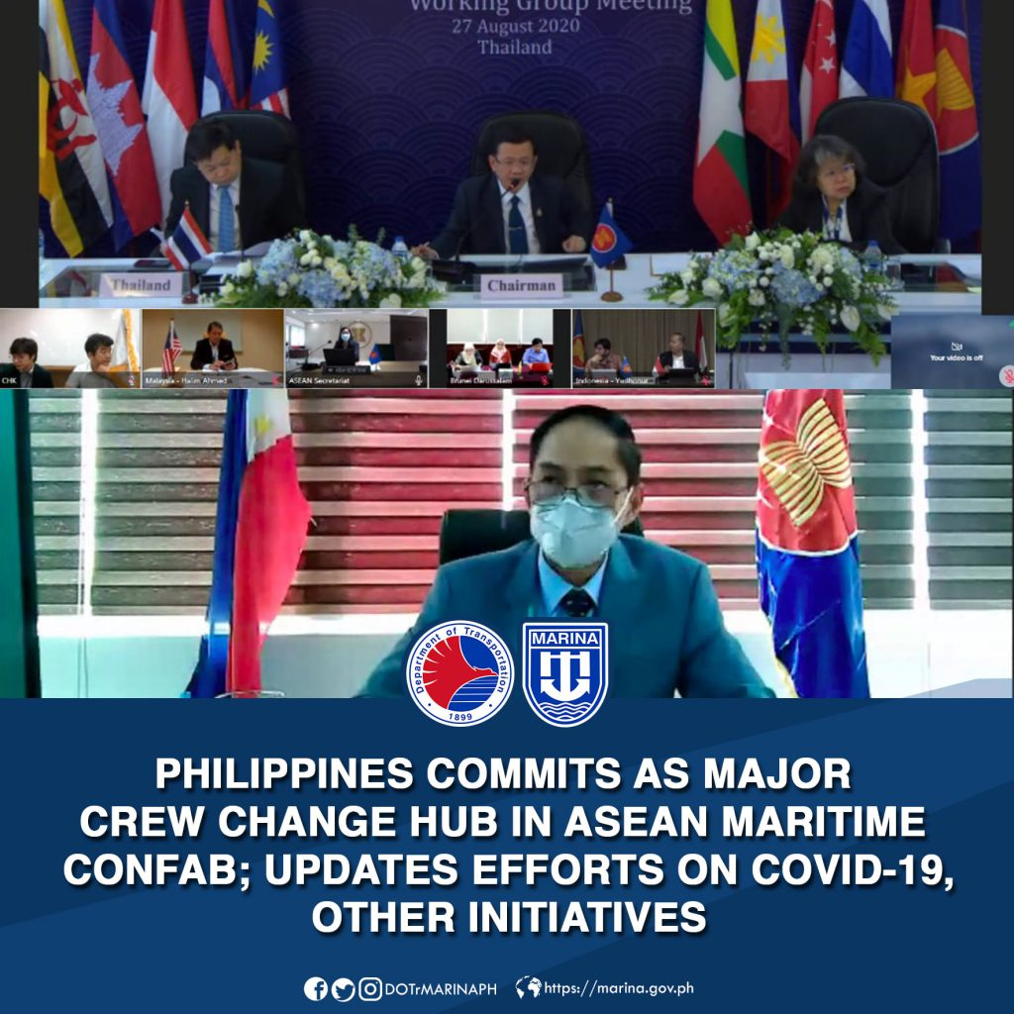

**39th Association of Southeast Asian Nations (ASEAN) Maritime Transport Working Group**

The Philippines, through the Maritime Industry Authority (MARINA), on Thursday committed itself to becoming a major international hub for crew change before the 39th Meeting of the Maritime Transport Working Group of the Association of Southeast Asian Nations (ASEAN) and its Dialogue Partners such as China, Japan, Korea and the International Maritime Organization (IMO). This is the first time that the meeting was held virtually amidst the COVID-19 pandemic.

[View More >](https://marina.gov.ph/2020/08/28/philippines-commits-as-major-crew-change-hub-in-asean-maritime-confab-updates-efforts-on-covid-19-other-initiatives/)

When ‘View More’ is clicked, the reader will be redirected to:

https://marina.gov.ph/2020/08/28/philippines-commits-as-major-crew-change-hub-in-asean-maritime-confab-updates-efforts-on-covid-19-other-initiatives/

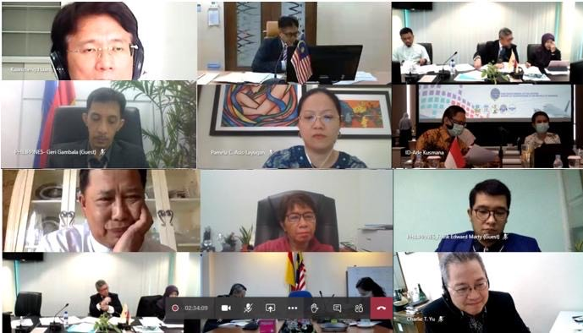

**Special Meeting of the BIMP-EAGA Air Linkages Working Group**

The Brunei Darussalam, Indonesia, Malaysia, Philippines-East ASEAN Growth Area (BIMP-EAGA) Air Linkages Working Group met virtually on 18 August 2020 to share their experienceson the Sector Impact, Government Responses and Recovery Measures in addressing the global crisis brought about by COVID-19 pandemic.

[View More >](https://www.bimp-eaga.asia/article/working-group-discusses-ways-bring-back-air-transport)

When ‘View More’ is clicked, the reader will be redirected to:

<https://www.bimp-eaga.asia/article/working-group-discusses-ways-bring-back-air-transport>

* **July**

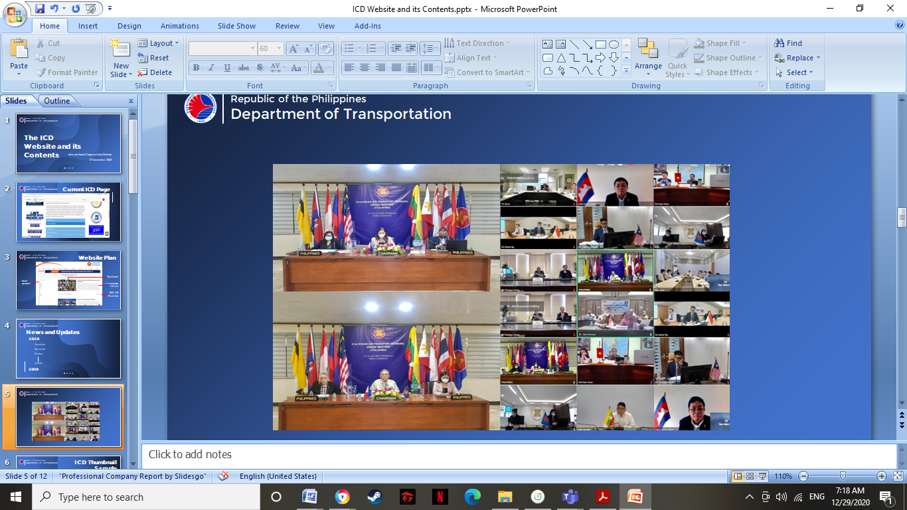

**41st Association of Southeast Asian Nations (ASEAN) Air Transport Working Group Meeting (ATWG)**

The Philippines, through the Department of Transportation (DOTr) and its attached agencies, hosted the 41st Association of Southeast Asian Nations (ASEAN) Air Transport Working Group Meeting (ATWG) and Related Meetings from 21 to 22 July 2020, via video conference.

[View More >](https://www.facebook.com/DOTrPH/posts/1762658203873308)

When ‘View More’ is clicked, the reader will be redirected to:

https://www.facebook.com/DOTrPH/posts/1762658203873308

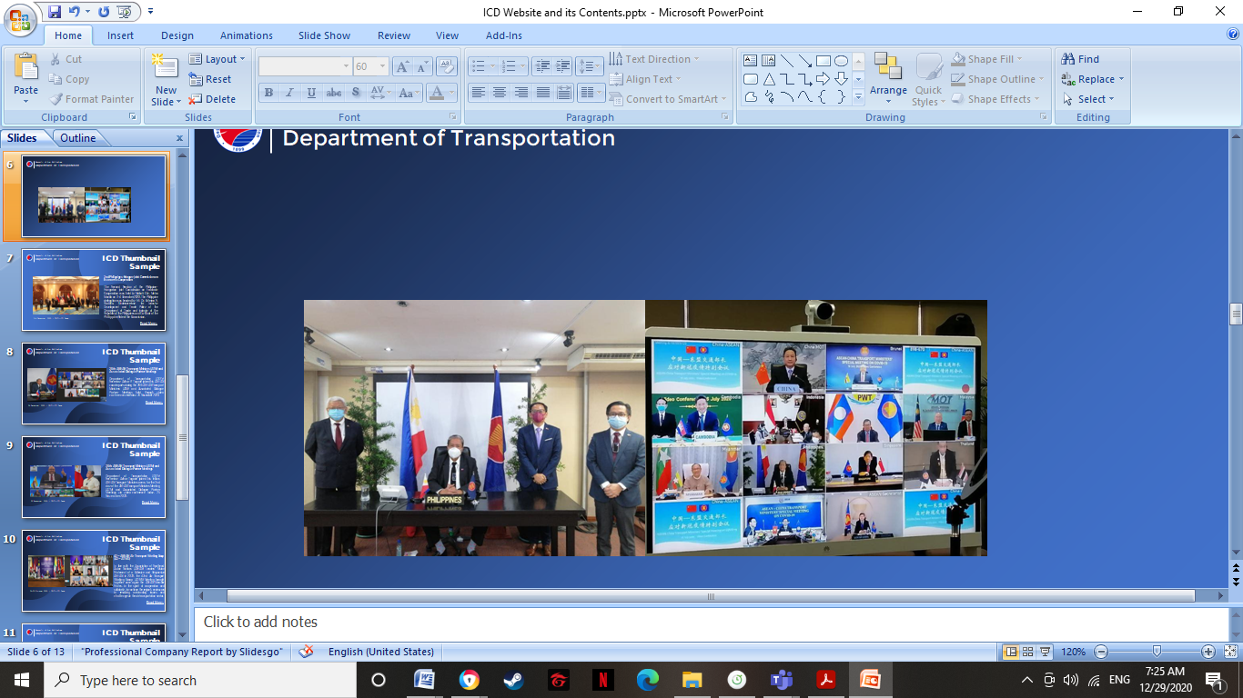

**ASEAN-China Special Transport Ministers Meeting**

Department of Transportation Secretary Arthur P. Tugade attended the ASEAN-CHINA Transport Ministers Special Meeting on COVID-19 via Videoconference on 16 July 2020.

[View More>](https://www.facebook.com/DOTrPH/posts/1756764461129349)

When ‘View More’ is clicked, the reader will be redirected to:

https://www.facebook.com/DOTrPH/posts/1756764461129349

* **June**
* **May**

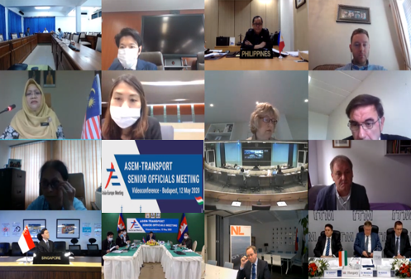

**ASEM Transport Senior Officials’ Meeting Videoconference**

Asia-Europe (ASEM) Transport Senior Officials’ Meeting was held virtually on 12 May 2020 with the participation of representatives from 35 ASEM Partner Countries and the European Commission. Hosted by the Hungarian Ministry for Innovation and Technology responsible for transport, the Philippines was represented by Undersecretary for Administrative Service Artemio U. Tuazon, Jr.

[View More >](https://www.aseminfoboard.org/events/asem-transport-senior-officials-meeting-asem-tsom-1)

When ‘View More’ is clicked, the reader will be redirected to:

<https://www.aseminfoboard.org/events/asem-transport-senior-officials-meeting-asem-tsom-1>

* **April**
* **March**
* **February**
* **January**